Merge Sort
Mergesort is a divide-and-conquer strategy based on the idea of dividing problem into smaller problems and solved recursively. The conquering phase consists of patching together the answers.

The mergesort algorithm is therefore easy to describe. If n = 1, there is only one element to sort and the answer is at hand. Otherwise, recursively mergesort the first half and the second. This gives two sorted halves, which can then be merged together using the merging algorithm.

void mergeSort(int a[ ], int tmp_array[ ], int left, int right)
{
int center;
if (left < right)
{
center = (left + right) / 2;
mergeSort(a, tmp_array, left, center);
mergeSort(a, tmp_array, center+1, right);
merge(a, tmp_array, left, center+1, right);
}
}

void merge(int a[ ], int tmp_array[ ], int l_pos, int r_pos, int right_end)
{
int i, left_end, num_elements, tmp_pos;
left_end = r_pos – 1;
tmp_pos = l_pos;
num_elements = right_end - l_pos + 1;
while( ( l_pos <= left_end ) && ( r_pos <= right_end ) )
if( a[l_pos] <= a[r_pos] )
tmp_array[tmp_pos++] = a[l_pos++];
else
tmp_array[tmp_pos++] = a[r_pos++];
while( l_pos <= left_end )
tmp_array[tmp_pos++] = a[l_pos++];
while( r_pos <= right_end )
tmp_array[tmp_pos++] = a[r_pos++];

# copy tmp_array back
for(i=1; i <= num_elements; i++, right_end--)
a[right_end] = tmp_array[right_end];
}

Example:

The operation of the algorithm on the list 8, 3, 2, 9, 7, 1, 5, 4 is shown below:
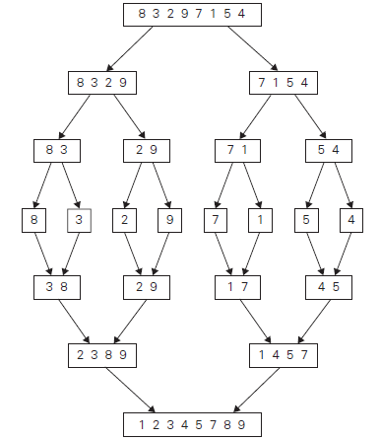
Time Complexity:
Basic Operation:
The basic operation is the key comparison.
B[i] ≤C[j]
Assuming for simplicity that n is a power of 2, the recurrence relation for the number of key comparison is
C(n)=2C(n/2)+C_{merge}(n) for n>1
C(1)=0
C_{merge}(n) is the number of key comparison performed during the merging stage.

Neither of the two arrays becomes empty before the other one contains just one element come from the alternating arrays.
Therefore,
C_{merge}(n)=n-1
and the recurrence relation becomes,
C_{worst}(n)=2C_{worst}(n/2)+n-1 for n>1
C_{worst}(1)=0
Put n=2^{k}
C_{worst}(2^{k})=2 C_{worst}(2^{k}/2)+2^{k} - 1
C_{worst}(2^{k}) = 2 C_{worst}(2^{k-1})+2^{k} - 1
=2[2C_{worst}(2^{k-2})+2^{k-1}-1]+2^{k} - 1
=2²C_{worst}(2^{k-2})+2.2^{k-1} - 2+2^{k} - 1
=2²C_{worst}(2^{k-2})+2^{k}+2^{k} – 2 - 1
=2²C_{worst}(2^{k-2})+2.2^{k} - 3
=2²C_{worst}(2^{k-2})+2.2^{k} - 2² + 1
=2³C_{worst}(2^{k-3})+3.2^{k} - 2³+1
As a generalisation,
C_{worst}(2^{k})= 2^{i}C_{worst}(2^{k-i})+i.2^{k} - 2^{i}+1
Sub i=k,
C_{worst}(2^{k})= 2^{k}C_{worst}(2^{k-k})+k.2^{k} - 2^{k}+1
=2^{k}C_{worst}(1)+k.2^{k} - 2^{k}+1
=0+k.2^{k}-2^{k}+1
C_{worst}(2^{k})= 2^{k}(k-1)+1.............. (1)

Taking log on both side, n=2^{k}
log₂n= log ₂2^{k}
log₂n =k log ₂2
log₂n=k
k=log₂n

Sub k= log₂n and 2^{k}=n in the equation (1)
C_{worst}(n)=n(log₂n-1)+1
=n log₂n-n+1
C_{worst}(n) = θ(n log₂n)

